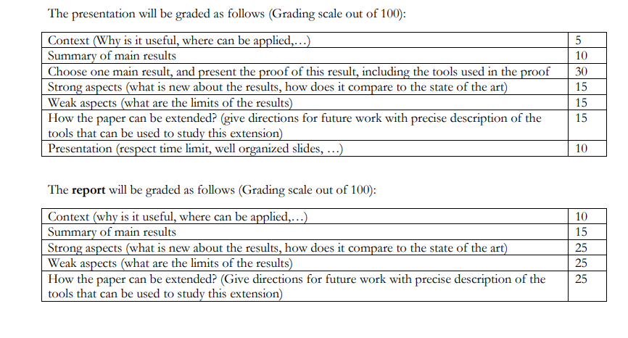

Must follow these guidelines due by October 18

